http://groupware.les.inf.puc-rio.br/public/papers/2013.Velloso.QAR-WLE.pdf

For data recording we used four 9 degrees of freedom Razor inertial measurement units (IMU), which provide three-axes acceleration, gyroscope and magnetometer data at a joint sampling rate of 45 Hz

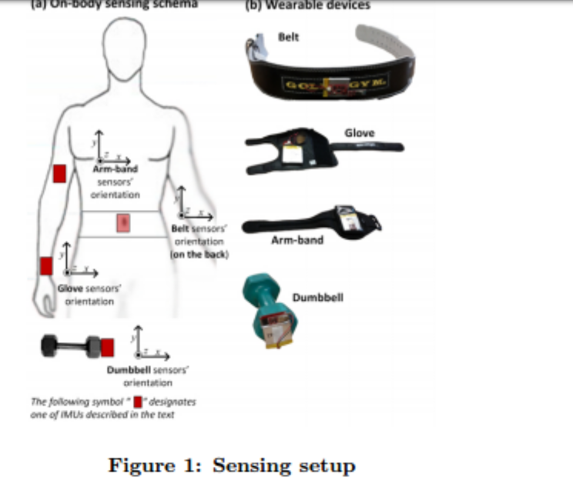
We mounted the sensors in the users’ glove, armband, lumbar belt and dumbbell (see Figure 1).
Participants were asked to perform one set of 10 repetitions of the Unilateral Dumbbell Biceps Curl in five different fashions: exactly according to the specification (Class A), throwing the elbows to the front (Class B), lifting the dumbbell only halfway (Class C), lowering the dumbbell only halfway (Class D) and throwing the hips to the front (Class E). Class A corresponds to the specified execution of the exercise, while the other 4 classes correspond to common mistakes

For feature extraction we used a sliding window approach with different lengths from 0.5 second to 2.5 seconds, with 0.5 second overlap. In each step of the sliding window approach we calculated features on the Euler angles (roll, pitch and yaw), as well as the raw accelerometer, gyroscope and magnetometer readings. For the Euler angles of each of the four sensors we calculated eight features: mean, variance, standard deviation, max, min, amplitude, kurtosis and skewness, generating in total 96 derived feature sets. 3x4x8=96

In order to identify the most relevant features we used the feature selection algorithm based on correlation proposed by Hall [14]. The algorithm was configured to use a “Best First” strategy based on backtracking.
17 features were selected:
- in the belt, were selected the mean and variance of the roll, maximum, range and variance of the accelerometer vector, variance of the gyro and variance of the magnetometer.
- In the arm, the variance of the accelerometer vector and the maximum and minimum of the magnetometer were selected.
- In the dumbbell, the selected features were the maximum of the acceleration, variance of the gyro and maximum and minimum of the magnetometer, while
- in the glove, the sum of the pitch and the maximum and minimum of the gyro were selected.

